Practical 9

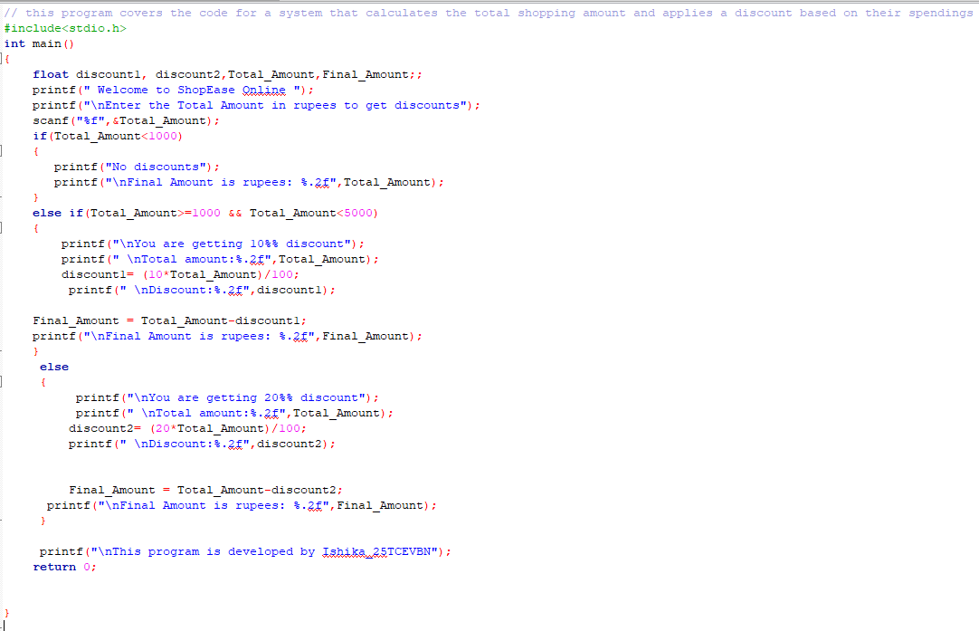

When the total amount is less than rupees 1000

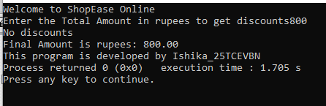

When the total amount is greater than or equal to rupees 1000 and less than rupees 5000

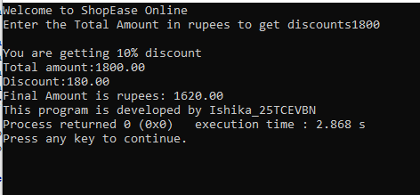

When the total amount is greater than or equal to rupees 5000

